**LAB EXAM -(2)**

### NAME:SATHWIK

### H.NO: 2403a51273

### BATCH:12

### SUB GROUP:N

### N.1 — [S18N1] Compute directory sizes from listing

Context:

Folder size accounting in real estate listings platform.

Your Task:

Aggregate child sizes to parent paths.

Data & Edge Cases:

Listing '/a 10', '/a/b 5', '/a/c 7'.

AI Assistance Expectation:

Prefix-walk strategy + tests.

Constraints & Notes:

Include parents once.

Sample Input

['/a 10', '/a/b 5', '/a/c 7']

Sample Output

{'/a':22,'/a/b':5,'/a/c':7}

Acceptance Criteria: Parents include children

### CODE:

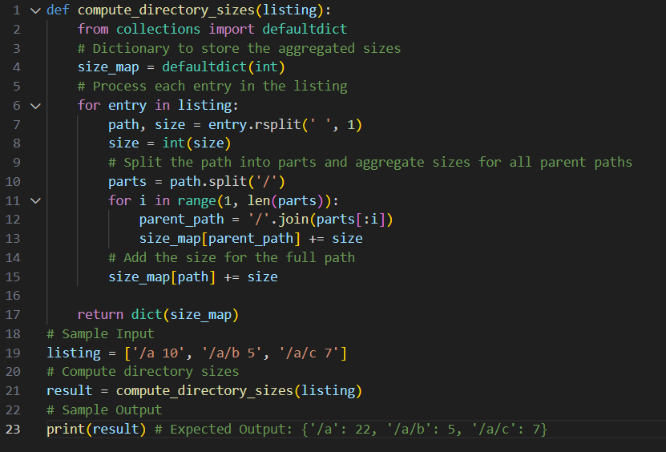

### Output



### N2-[S18N2] Compute simple sentiment score

Context:

Lexicon-based sentiment in real estate listings platform.

Your Task:

Score with good=+1, great=+2, bad=-1.

Data & Edge Cases:

Tokenize on spaces; strip punctuation.

AI Assistance Expectation:

AI for tests and simple tokenizer.

Constraints & Notes:

Return integer sum.

Sample Input

good product with bad packaging but great value

Sample Output

2

Acceptance Criteria: Correct sum

### CODE:

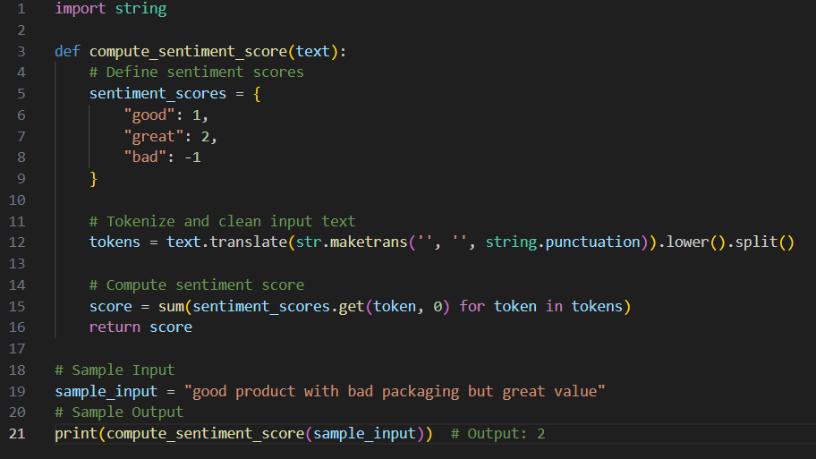

### Output

2